**Chapter 3**

**Vector-Valued Functions**

**3.3 Arc Length and Curvature**

**Section Exercises**

**Find the arc length of the curve on the given interval.**

1.  This portion of the graph is shown here:

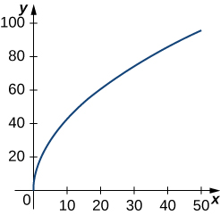

Answer: 112.5 units

1. 

Answer: 

1.  This portion of the graph is shown here:

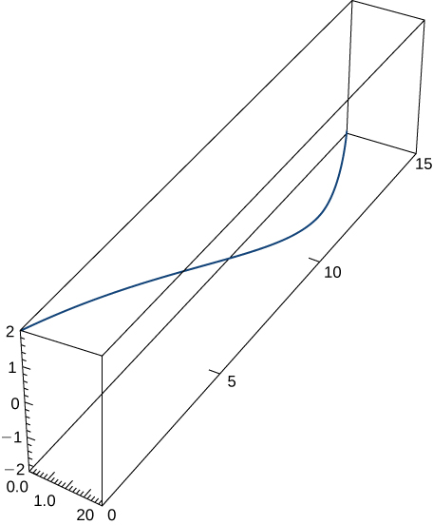

Answer: 

1. 

Answer: 

1.  over the interval  Here is the portion of the graph on the indicated interval:

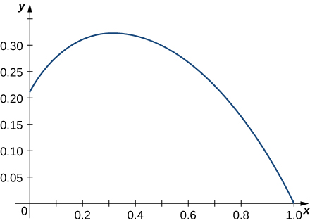

Answer: 

1. Find the length of one turn of the helix given by 

Answer: Length

1. Find the arc length of the vector-valued function  over 

Answer: 

1. A particle travels in a circle with the equation of motion  Find the distance traveled around the circle by the particle.

Answer: 

1. Set up an integral to find the circumference of the ellipse with the equation 

Answer: The integration cannot be performed by hand; but, using technology

1. Find the length of the curve  over the interval  The graph is shown here:

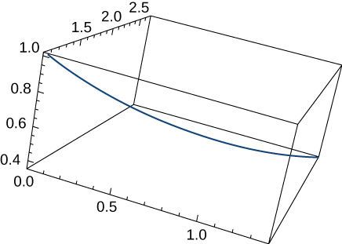

Answer: 

1. Find the length of the curve  for 

Answer: 

1. The position function for a particle is  Find the unit tangent vector and the unit normal vector at 

Answer:  

1. Given  find the binormal vector 

Answer: 

1. Given  determine the unit tangent vector 

Answer: 

1. Given  determine the unit tangent vector  evaluated at 

Answer: 

1. Given  find the unit normal vector  evaluated at  

Answer: 

1. Given  find the unit normal vector evaluated at 

Answer: 

1. Given  find the unit tangent vector  The graph is shown here:

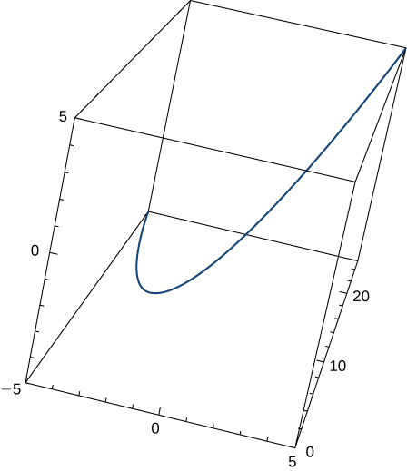

Answer: 

1. Find the unit tangent vector  and unit normal vector  at  for the plane curve  The graph is shown here:

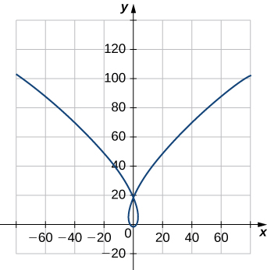

Answer:  

1. Find the unit tangent vector  for 

Answer: 

1. Find the principal normal vector to the curve  at the point determined by 

Answer: 

1. Find  for the curve 

Answer: 

1. Find  for the curve 

Answer: 

1. Find the unit normal vector  for 

Answer: 

1. Find the unit tangent vector  for 

Answer: 

1. Find the arc-length function  for the line segment given by  Write *r* as a parameter of *s.*

Answer: Arc-length function:  r as a parameter of *s*: 

1. Parameterize the helix  using the arc-length parameter *s*, from 

Answer: 

1. Parameterize the curve using the arc-length parameter *s*, at the point at which  for 

Answer: 

1. Find the curvature of the curve  at  (Note: The graph is an ellipse.)

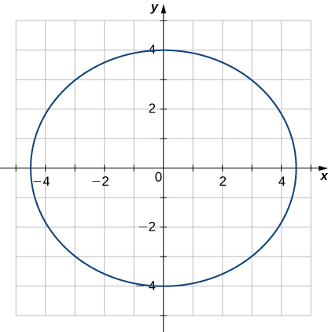

Answer: 

1. Find the *x*-coordinate at which the curvature of the curve  is a maximum value.

Answer: The maximum value of the curvature occurs at 

1. Find the curvature of the curve  Does the curvature depend upon the parameter *t*?

Answer: The curvature is that of a circle with radius 5. The curvature of a circle is the reciprocal of the radius and is thus equal to  for any value of *t*.

1. Find the curvature  for the curve  at the point 

Answer: 

1. Find the curvature  for the curve  at the point 

Answer: 

1. Find the curvature  of the curve  The graph is shown here:

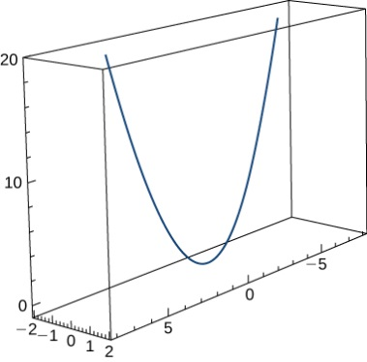

Answer: 

1. Find the curvature of 

Answer: 

1. Find the curvature of  at point 

Answer: 

1. At what point does the curve  have maximum curvature?

Answer: 

1. What happens to the curvature as  for the curve 

Answer: The curvature approaches zero.

1. Find the point of maximum curvature on the curve 

Answer: 

1. Find the equations of the normal plane and the osculating plane of the curve  at point 

Answer:  and 

1. and 

Answer:  

1. Find the equation for the osculating plane at point  on the curve 

Answer: 

1. Find the radius of curvature of  at the point 

Answer: 

1. Find the curvature at each point  on the hyperbola 

Answer: 

1. Calculate the curvature of the circular helix 

Answer: 

1. Find the radius of curvature of  at point 

Answer: 

1. Find the radius of curvature of the hyperbola  at point 

Answer: 

**A particle moves along the plane curve C described by  Solve the following problems.**

1. Find the length of the curve over the interval 

Answer: 

1. Find the curvature of the plane curve at 

Answer: 

1. Describe the curvature as *t* increases from  to 

Answer: The curvature is decreasing over this interval.

**The surface of a large cup is formed by revolving the graph of the function  from  to  about the *y*-axis (measured in centimeters).**

1. **[T]** Use technology to graph the surface.

Answer:

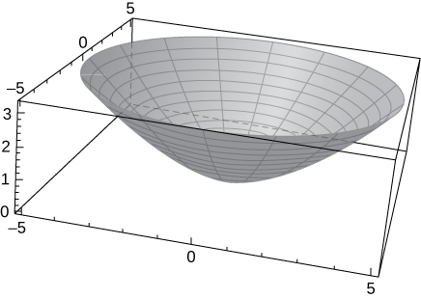

1. Find the curvature  of the generating curve as a function of *x.*

Answer: 

1. **[T]** Use technology to graph the curvature function.

Answer:

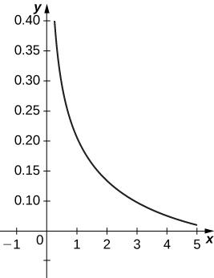

This file is copyright 2016, Rice University. All Rights Reserved.